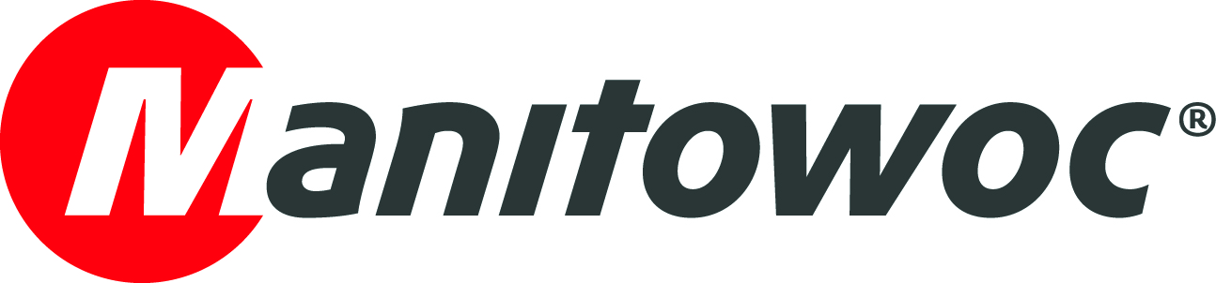
CAPTION RELEASE

July 2, 2019

Four GMK4100L-1 all-terrain cranes complete Spanish rental fleet

Manitowoc has delivered four Grove GMK4100L-1 all-terrain cranes to Spanish rental company Transportes y Grúas Aguado. Headquartered in Madrid, Transportes y Grúas Aguado has seven premises across the country and specializes in the transport and lifting of large loads.

“We chose the Grove GMK4100L-1 because it can be used for a multitude of jobs and different applications,” said Juan Aguado, president of Transportes y Grúas Aguado. “We particularly liked the agility and mobility, thanks to the Megatrak™ suspension system and all-wheel drive. We are often required to provide high load capacities in small, hard-to-access jobsites; for those jobs, the GMK4100L-1 is perfect. The four new machines now complete our fleet.”

The 100-t capacity GMK4100L-1 is part of Grove’s long-boom series of all terrain cranes. It was launched in 2016 following the success of the GMK4100L, which it replaced. It offers unique innovations and class-leading capabilities in the taxi (road travelling) category. It also boasts the best load charts in its class and its compact design makes it easy to access and maneuver on the narrowest jobsites.

-END-

Image caption: One of four new Grove GMK4100L-1 all-terrain cranes to join Transportes y Grúas Aguado's rental fleet

CONTACT
Insa Heim
Manitowoc Cranes
T +49 4421 294 4170
insa.heim@manitowoc.com

ABOUT THE MANITOWOC COMPANY, INC.
The Manitowoc Company, Inc. (“Manitowoc”) was founded in 1902 and has over a 116-year tradition of providing high-quality, customer-focused products and support services to its markets and its 2018 net sales were approximately $1.8 billion. Manitowoc is one of the world's leading providers of engineered lifting solutions. Manitowoc, through its wholly-owned subsidiaries, designs, manufactures, markets, and supports comprehensive product lines of mobile telescopic cranes, tower cranes, lattice-boom crawler cranes, and boom trucks under the Grove, Manitowoc, National Crane, Potain, Shuttlelift and Manitowoc Crane Care brand names.

THE MANITOWOC COMPANY, INC.
One Park Plaza – 11270 West Park Place – Suite 1000 – Milwaukee, WI 53224, USA
T +1 920 684 4410
www.manitowoc.com

